Software Engineering

HDCBIS Group Assignment

NIBM Academic Records Management System

13.2

Amenda Fernando

Panchala Rathnayake

GMT

Janitha Madushan

13.2

## Acknowledgement

We thank the staff of NIBM all other who gave us the fullest support in guiding, advising and giving us knowledge upon which we build our future careers.

Last but not least we thank all those whose names, though not mentioned for their help and encouragement in completing this project.

OUR SINCERE THANKS TO ALL.

# Content

Contents

Acknowledgement 2

Benefits of proposed system 3

Content 4

Context Level 5

Level 0 6

Level 1 7

File Design 8

SQL Commands 28

Report Generation 31

# Benefits of propose system

Assumptions

# Context Level

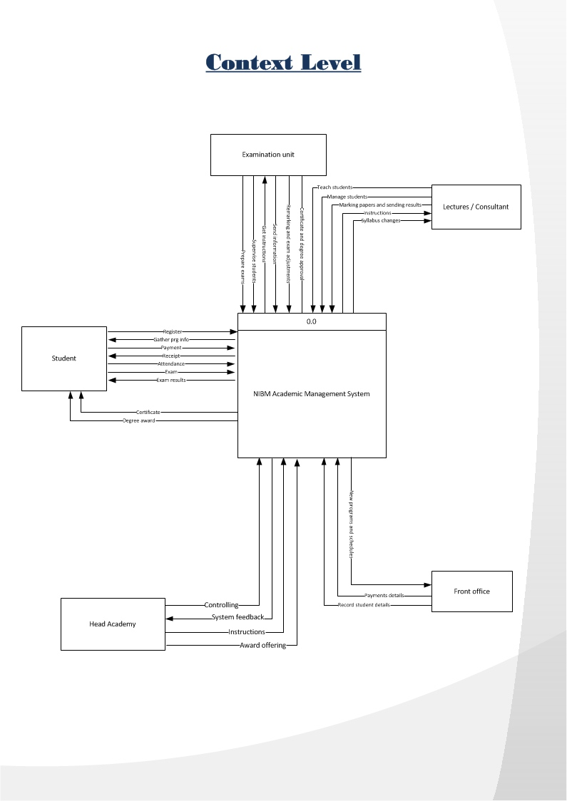

# Level 0

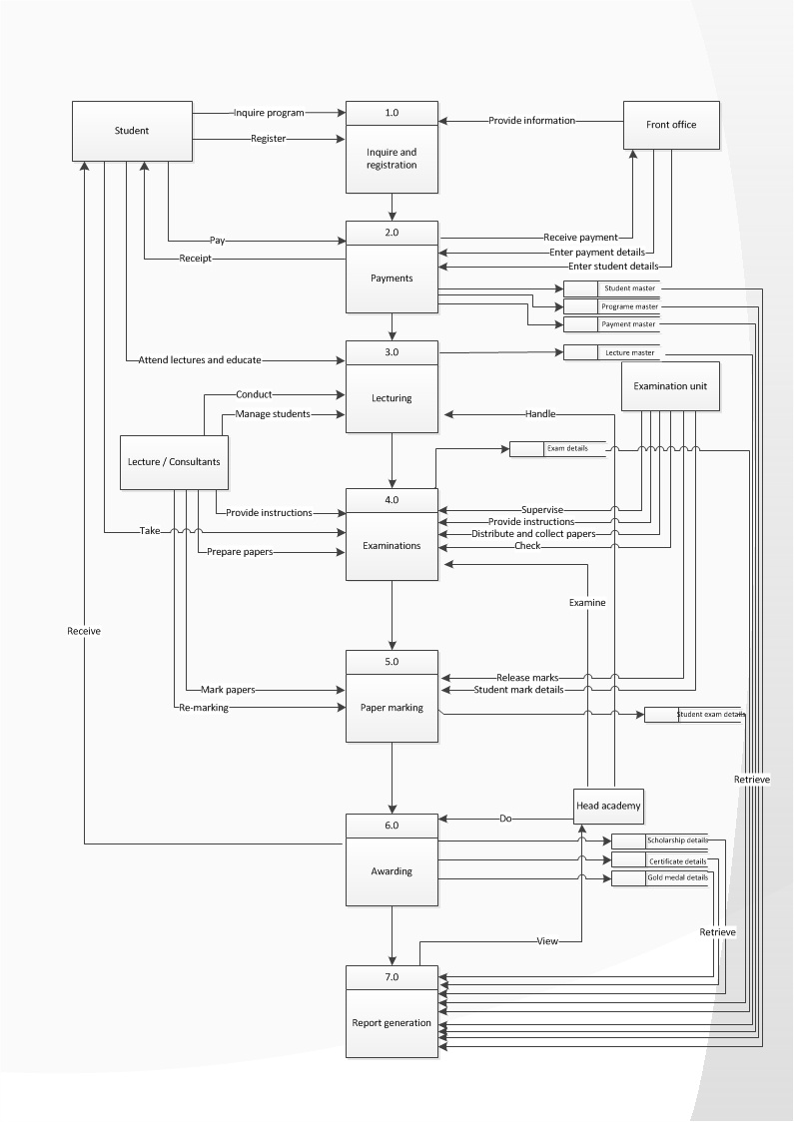

# File Design

|  |  |
| --- | --- |
| File no | File name |
| F01 | Student Master |
| F02 | Lecturer Master |
| F03 | Programme Master |
| F04 | Examination Board Master |
| F05 | Unit Head Details |
| F06 | Module Details |
| F07 | Student Batch Details |
| F08 | Exam Details |
| F09 | Batch Details |
| F10 | Student Exam Details |
| F11 | Payment Master |
| F12 | Payment Details |
| F13 | Student suspension Details |
| F14 | Certificate Receiver Details |
| F15 | Gold Medal details |
| F16 | Scholarship Details |
| F17 | Student Attendance Details |
| F18 | Lecture Attendance Details |

**File No : - F01**

**File Name : - Student_Master**

**File Description : - Students’ Details**

**Record Size : - 200**

**Primary Key : -Std_ID**

**File Organization : - Index**

|  |  |  |  |  |
| --- | --- | --- | --- | --- |
| **Field No** | **Field Name** | **Description** | **Field Type** | **Field Size** |
| 01 | Std_ID | Student Number | Number | 12 |
| 02 | Std_Name | Student Name | Text | 30 |
| 03 | NIC | NIC Number | Text | 10 |
| 04 | Gender | Gender | Text | 6 |
| 05 | DOB | Date Of Birth | Date | 10 |
| 06 | Address | Address | Text | 60 |
| 07 | Contact_No | Contact Number | Number | 10 |
| 08 | Email | E-mail | Text | 25 |
| 09 | Regi_Date | Registration Date | Date | 20 |
| 10 | Regi_Time | Registration Time | Text | 8 |

**File No : - F02**

**File Name : - Lecturer_Master**

**File Description : - Lecturer Details**

**Record Size : - 80**

**Primary Key : - Lect_ID**

**File Organization : - Index**

|  |  |  |  |  |
| --- | --- | --- | --- | --- |
| **Field No** | **Field Name** | **Description** | **Field Type** | **Field Size** |
| 01 | Lect_ID | Lecturer ID | Text | 10 |
| 02 | Name | Lecturer’s Name | Text | 20 |
| 03 | Division | Division | Text | 40 |
| 04 | Center | Lecturer’s Center | Text | 10 |

|  |  |  |  |  |
| --- | --- | --- | --- | --- |
| **Field No** | **Field Name** | **Description** | **Field Type** | **Field Size** |
| 01 | Pgrm_ID | Programme Code | Text | 4 |
| 02 | Division | Division | Text | 40 |
| 03 | Type | Programme Type | Text | 25 |
| 04 | Prg_Name | Programme Name | Text | 45 |
| 05 | Prg_Director | Programme Director’s Name | Text | 20 |

**File No : - F03**

**File Description : - Programme_Master**

**Record Size : - 135**

**Primary Key : - prgm_ID**

**File Organization : - Index**

**File No : - F04**

**File Name : - Examination Board_Master**

**File Description : - Examination Board Details**

**Record Size : - 35**

**Primary Key : - Exam_Off_ID**

**File Organization : - Index**

|  |  |  |  |  |
| --- | --- | --- | --- | --- |
| **Field No** | **Field Name** | **Description** | **Field Type** | **Field Size** |
| 01 | ExamOff_ID | Exam Officer ID | Text | 5 |
| 02 | ExamOff_Name | Exam Officer Name | Text | 20 |
| 03 | Contact_No | Contact Number | Number | 10 |

**File No : - F05**

**File Name : Unit Head_Details**

**File Description : - Unit Head Details**

**Record Size : - 50**

**Primary Key : - UHead _ID**

**Foreign Key : - Lect_ID**

**File Organization : - Sequential**

|  |  |  |  |  |
| --- | --- | --- | --- | --- |
| **Field No** | **Field Name** | **Description** | **Field Type** | **Field Size** |
| 01 | UHead_ID | Unit Head ID | Text | 5 |
| 02 | Lect_ID | Lecturer ID | Text | 5 |
| 03 | Name | Unit Head’s Name | Text | 20 |
| 04 | Center | Center | Text | 10 |
| 05 | Contact_No | Contact Number | Number | 10 |

**File No : - F06**

**File Name : - Module_Deatils**

**File Description : - Module Details**

**Record Size : - 30**

**Primary Key : - Mdl_ID**

**Foreign Key : - Lect_ID**

**File Organization : - Sequential**

|  |  |  |  |  |
| --- | --- | --- | --- | --- |
| **Field No** | **Field Name** | **Description** | **Field Type** | **Field Size** |
| 01 | Mdl_ID | Module ID | Text | 4 |
| 02 | Module_Name | Module Name | Text | 20 |
| 03 | Lect_ID | Lecturer ID | Text | 5 |
| 04 | Credit_Points | Credit Points | Number | 1 |

**File No : - F07**

**File Name : - Student Batch_Details**

**File Description : - Student Batch Details**

**Record Size : 18**

**Foreign Key : -Std_ID,Batch_Code, Pgrm_Code**

**File Organization : - Sequential**

|  |  |  |  |  |
| --- | --- | --- | --- | --- |
| **Field No** | **Field Name** | **Description** | **Field Type** | **Field Size** |
| 01 | Std_ID | Student Number | Number | 8 |
| 02 | Batch_Code | Batch Code | Number | 6 |
| 03 | Pgrm_Code | Programme Code | Text | 4 |

**File No : - F08**

**File Name : - Exam_Details**

**File Description : - Examinations’ Details**

**Record Size : - 38**

**Primary Key : -Exam_Code**

**Foreign Key : - Mdl_ID**

**File Organization : - Sequential**

|  |  |  |  |  |
| --- | --- | --- | --- | --- |
| **Field No** | **Field Name** | **Description** | **Field Type** | **Field Size** |
| 01 | Exam_Code | Examination Code | Number | 6 |
| 02 | Module_ID | Module ID | Text | 4 |
| 03 | Date | Date | Date | 28 |

**File No : - F09**

**File Name : - Batch_Details**

**File Description : - Batch Details**

**Record Size : - 85**

**Primary Key : - The row itself**

**Foreign Key : - Pgrm_Code**

**File Organization : - Sequential**

|  |  |  |  |  |
| --- | --- | --- | --- | --- |
| **Field No** | **Field Name** | **Description** | **Field Type** | **Field Size** |
| 01 | Batch_Code | Batch Code | Number | 6 |
| 02 | Pgrm_Code | Programme Code | Text | 4 |
| 03 | Start_Date | Start Date | Date | 20 |
| 04 | End_Date | End Date | Date | 20 |
| 05 | Status | Status | Text | 6 |
| 06 | Center | Center of given batch | Text | 10 |
| 07 | Programme_Director | Programme Director’s Name | Text | 20 |

**File No : - F10**

**File Name : - Student Exam_Details**

**File Description : - Students’ Examination Details**

**Record Size : - 18**

**Foreign Key : - Std_ID,Exam_Code**

**File Organization : - Sequential**

|  |  |  |  |  |
| --- | --- | --- | --- | --- |
| **Field No** | **Field Name** | **Description** | **Field Type** | **Field Size** |
| 01 | Std_ID | Student Number | Number | 8 |
| 02 | Exam_Code | Examination Code | Number | 6 |
| 03 | Status | Student’s Exam Participation | Text | 4 |

**File No : - F11**

**File Name : - Payment master**

**File Description : - Students’ payment Details**

**Record Size : - 36**

**Primary Key :- Payment_ID**

**Foreign Key : - Std_ID,Exam_Code**

**File Organization : - Sequential**

|  |  |  |  |  |
| --- | --- | --- | --- | --- |
| **Field No** | **Field Name** | **Description** | **Field Type** | **Field Size** |
| 01 | SPayment_ID | Student Payment ID number | Number | 8 |
| 02 | Std_ID | Student Number | Number | 8 |
| 03 | Date | Payment date | Date | 20 |

**File No : - F12**

**File Name : - Payment_Details**

**File Description : - Payment Details**

**Record Size : - 291**

**Primary Key :- Payment_ID**

**Foreign Key : - Std_ID**

**File Organization : - Sequential**

|  |  |  |  |  |
| --- | --- | --- | --- | --- |
| **Field No** | **Field Name** | **Description** | **Field Type** | **Field Size** |
| 01 | Payment_ID | Payment ID number | Number | 8 |
| 02 | Std_ID | Student Number | Number | 8 |
| 03 | Date | Payment date | Date | 20 |
| 04 | Desc | Description | Text | 255 |

**File No : - F13**

**File Name : - Student_Suspension_Details**

**File Description : - Students’ suspension Details**

**Record Size : - 291**

**Primary Key :- S_ID**

**Foreign Key : - Std_ID**

**File Organization : - Sequential**

|  |  |  |  |  |
| --- | --- | --- | --- | --- |
| **Field No** | **Field Name** | **Description** | **Field Type** | **Field Size** |
| 01 | S_ID | Student Suspension ID number | Number | 8 |
| 02 | Std_ID | Student Number | Number | 8 |
| 03 | Date | Payment date | Date | 20 |
| 04 | Des | Suspension description | Text | 255 |

**File No : - F14**

**File Name : - certificate_receiver_Details**

**File Description : - certificate received details of students**

**Record Size : - 46**

**Primary Key :- C_ID**

**Foreign Key : - Std_ID, Prgm_ID**

**File Organization : - Sequential**

|  |  |  |  |  |
| --- | --- | --- | --- | --- |
| **Field No** | **Field Name** | **Description** | **Field Type** | **Field Size** |
| 01 | C_ID | Certificate ID number | Number | 8 |
| 02 | Std_ID | Student Number | Number | 8 |
| 03 | Prgm_ID | Course ID | Text | 10 |
| 03 | Date | Payment date | Date | 20 |

**File No : - F15**

**File Name : - Gold_Medal_Details**

**File Description : - gold medal awarded details**

**Record Size : - 42**

**Primary Key :- M_ID**

**Foreign Key : - Std_ID**

**File Organization : - Sequential**

|  |  |  |  |  |
| --- | --- | --- | --- | --- |
| **Field No** | **Field Name** | **Description** | **Field Type** | **Field Size** |
| 01 | G_ID | Gold medal ID number | Number | 8 |
| 02 | Std_ID | Student Number | Number | 8 |
| 03 | Batch_code | Batch code | Number | 6 |
| 04 | Date | Award date | Date | 20 |

**File No : - F16**

**File Name : - Scholarship_Details**

**File Description : - Students’ scholarship Details**

**Record Size : - 291**

**Primary Key :- Sco_ID**

**Foreign Key : - Std_ID**

**File Organization : - Sequential**

|  |  |  |  |  |
| --- | --- | --- | --- | --- |
| **Field No** | **Field Name** | **Description** | **Field Type** | **Field Size** |
| 01 | Sco_ID | Student scholarship ID number | Number | 8 |
| 02 | Std_ID | Student Number | Number | 8 |
| 03 | Date | Payment date | Date | 20 |
| 04 | Des | Description | Text | 255 |

**File No : - F17**

**File Name : - Student_Attendance_Details**

**File Description : - Students’ attendance Details**

**Record Size : - 28**

**Primary Key :- Date**

**Foreign Key : - Std_ID**

**File Organization : - Sequential**

|  |  |  |  |  |
| --- | --- | --- | --- | --- |
| **Field No** | **Field Name** | **Description** | **Field Type** | **Field Size** |
| 01 | Date | Date | Date | 20 |
| 02 | Std_ID | Student Number | Number | 8 |

**File No : - F18**

**File Name : - Lec_Attendance_Details**

**File Description : - Lecturers attendance Details**

**Record Size : - 28**

**Primary Key :- Date**

**Foreign Key : - Lec_ID**

**File Organization : - Sequential**

|  |  |  |  |  |
| --- | --- | --- | --- | --- |
| **Field No** | **Field Name** | **Description** | **Field Type** | **Field Size** |
| 01 | Date | Date | Date | 20 |
| 02 | Lec_ID | Student Number | Number | 8 |

# SQL Commands

Student Master

*SELECT * FROM Student Master;

Lecture Master

*SELECT *FROM Lecture Master;

Programme Master

*SELECT * FROM Programme Master;

Board Master

*SELECT * FROM Examination Board Master;

Unit Head Details

*SELECT UHead_ID, Lect_ID and Center FROM Unit Head_Details;

Module details

*SELECT * FROM Module_Details WHERE Mdl_ID=selected value AND Prgm_code=selected value;

Student batch details

*SELECT * FROM Student_Batch_Details WHERE Pgrm_Code= Selected value AND Center=Selected Value;

Student Exam details

*SELECT * FROM Student_Exam_Details WHERE Exam_Code=Selected Value;

Batch details

*SELECT * FROM Batch_Details WHERE Pgrm_Code=Selected Value AND Center=Selected Value;

Student Exam details

*SELECT * FROM Student_Exam_Details WHERE Exam_Code=Selected Value;

Student Payment Details

*SELECT * FROM Student_Payment_Details WHERE SPayment_ID=selected value;

Student Suspension Details

*SELECT * FROM Student_Suspension_Details WHERE S_ID=selected Value AND Std_ID=Selected Value;

Certificate Receiver details

*SELECT * FROM Certificate_Receiver_Details WHERE C_ID=selected value;

Gold Medal details

*SELECT * FROM Gold_Medal_Details WHERE Pgrm_code=Selected Value AND Batch_code=Selected Value;

Scholarship details

*SELECT * FROM Scholarship_Details WHERE Sco_ID=selected value;

Student Attendances

*SELECT * FROM Student_Attendance-Details WHERE Std_ID=selected value;

Lec Attendance details

*SELECT * FROM Lec_Attendance_Details WHERE Lect_ID=selected value AND Center=Selected value;

# Report Generation

|  |  |
| --- | --- |
| Report No | Report Name |
| R01 | List of Gold Medal Winners |
| R02 | List of Scholarship Winner |
| R03 | List of Degree Certificates Receiver |
| R04 | List of Higher Diploma Certificate Receiver |
| R05 | List of Advance Diploma Certificate Receiver |
| R06 | List of Registered Participates of given |
| R07 | List of Suspended Students |
| F08 | Module Marks |
| F09 | Mark Sheet of a Batch |
| F10 | List of participation Who have with Drawn from a Batch |
|  |  |
|  |  |
|  |  |
|  |  |
|  |  |



**List of Gold medal Winners**

Year ………………………….

|  |  |  |
| --- | --- | --- |
| **ID** | **Student Name** | **Batch** |
|  |  |  |
|  |  |  |
|  |  |  |
|  |  |  |
|  |  |  |
|  |  |  |
|  |  |  |
|  |  |  |
|  |  |  |
|  |  |  |
|  |  |  |
|  |  |  |
|  |  |  |
|  |  |  |
|  |  |  |
|  |  |  |
|  |  |  |
|  |  |  |
|  |  |  |
|  |  |  |
|  |  |  |
|  |  |  |
|  |  |  |

………………………… ………………………… ……………………..

Prepared by Checked by Approved by



**List of Scholarship winners**

Year………………………

|  |  |  |
| --- | --- | --- |
| **ID** | **Student Name** | **Batch** |
|  |  |  |
|  |  |  |
|  |  |  |
|  |  |  |
|  |  |  |
|  |  |  |
|  |  |  |
|  |  |  |
|  |  |  |
|  |  |  |
|  |  |  |
|  |  |  |
|  |  |  |
|  |  |  |
|  |  |  |
|  |  |  |
|  |  |  |
|  |  |  |
|  |  |  |

.………………….. …………………………… .…………………

Prepared by Checked by Approved by



**List of Degree Certificates Receivers**

Year………………………..

|  |  |  |
| --- | --- | --- |
| **ID** | **Student Name** | **Batch** |
|  |  |  |
|  |  |  |
|  |  |  |
|  |  |  |
|  |  |  |
|  |  |  |
|  |  |  |
|  |  |  |
|  |  |  |
|  |  |  |
|  |  |  |
|  |  |  |
|  |  |  |
|  |  |  |
|  |  |  |
|  |  |  |
|  |  |  |
|  |  |  |
|  |  |  |

.………………….. …………………………… .…………………

Prepared by Checked by Approved by



**List of Higher Diploma Certificate Receivers**

Year…………………………………

|  |  |  |
| --- | --- | --- |
| **ID** | **Student Name** | **Batch** |
|  |  |  |
|  |  |  |
|  |  |  |
|  |  |  |
|  |  |  |
|  |  |  |
|  |  |  |
|  |  |  |
|  |  |  |
|  |  |  |
|  |  |  |
|  |  |  |
|  |  |  |
|  |  |  |
|  |  |  |
|  |  |  |
|  |  |  |
|  |  |  |
|  |  |  |

.………………….. …………………………… .…………………

Prepared by Checked by Approved by



**List of Advance Diploma Certificate Receivers**

Year………………………..

|  |  |  |
| --- | --- | --- |
| **ID** | **Student Name** | **Batch** |
|  |  |  |
|  |  |  |
|  |  |  |
|  |  |  |
|  |  |  |
|  |  |  |
|  |  |  |
|  |  |  |
|  |  |  |
|  |  |  |
|  |  |  |
|  |  |  |
|  |  |  |
|  |  |  |
|  |  |  |
|  |  |  |
|  |  |  |
|  |  |  |
|  |  |  |

.………………….. …………………………… .…………………

Prepared by Checked by Approved by



**List of Registered Participates of a given**

Program and batch: ......

|  |  |  |  |
| --- | --- | --- | --- |
| **ID** | **Student Name** | **Program** | **Batch** |
|  |  |  |  |
|  |  |  |  |
|  |  |  |  |
|  |  |  |  |
|  |  |  |  |
|  |  |  |  |
|  |  |  |  |
|  |  |  |  |
|  |  |  |  |
|  |  |  |  |
|  |  |  |  |
|  |  |  |  |
|  |  |  |  |
|  |  |  |  |
|  |  |  |  |
|  |  |  |  |
|  |  |  |  |
|  |  |  |  |
|  |  |  |  |
|  |  |  |  |
|  |  |  |  |
|  |  |  |  |
|  |  |  |  |

.………………….. …………………………… .…………………

Prepared by Checked by Approved by



**List of suspended students.**

Year……………….

|  |  |  |  |
| --- | --- | --- | --- |
| **ID** | **Student Name** | **Reason** | **Batch** |
|  |  |  |  |
|  |  |  |  |
|  |  |  |  |
|  |  |  |  |
|  |  |  |  |
|  |  |  |  |
|  |  |  |  |
|  |  |  |  |
|  |  |  |  |
|  |  |  |  |
|  |  |  |  |
|  |  |  |  |
|  |  |  |  |
|  |  |  |  |
|  |  |  |  |
|  |  |  |  |
|  |  |  |  |
|  |  |  |  |
|  |  |  |  |
|  |  |  |  |
|  |  |  |  |
|  |  |  |  |
|  |  |  |  |

………………………… ………………………… ……………………..

Prepared by Checked by Approved by



**Module marks**

Module Name…………………………..

|  |  |  |  |
| --- | --- | --- | --- |
| **ID** | **Student Name** | **Mark** | **Grade** |
|  |  |  |  |
|  |  |  |  |
|  |  |  |  |
|  |  |  |  |
|  |  |  |  |
|  |  |  |  |
|  |  |  |  |
|  |  |  |  |
|  |  |  |  |
|  |  |  |  |
|  |  |  |  |
|  |  |  |  |
|  |  |  |  |
|  |  |  |  |
|  |  |  |  |
|  |  |  |  |
|  |  |  |  |
|  |  |  |  |
|  |  |  |  |

………………………… ………………………… ……………………..

Prepared by Checked by Approved by



**Mark sheet of a batch**

Year………………

|  |  |  |  |  |  |
| --- | --- | --- | --- | --- | --- |
| **ID** | **Student Name** | **Grade** | | | |
| VB | OOP | C++ | .Net |
|  |  |  |  |  |  |
|  |  |  |  |  |  |
|  |  |  |  |  |  |
|  |  |  |  |  |  |
|  |  |  |  |  |  |
|  |  |  |  |  |  |
|  |  |  |  |  |  |
|  |  |  |  |  |  |
|  |  |  |  |  |  |
|  |  |  |  |  |  |
|  |  |  |  |  |  |
|  |  |  |  |  |  |
|  |  |  |  |  |  |
|  |  |  |  |  |  |
|  |  |  |  |  |  |
|  |  |  |  |  |  |
|  |  |  |  |  |  |
|  |  |  |  |  |  |

………………………… ………………………… ……………………..

Prepared by Checked by Approved by



**List of participants who have withdrawn from a batch**

|  |  |  |
| --- | --- | --- |
| **ID** | **Student Name** | **Payment** |
|  |  |  |
|  |  |  |
|  |  |  |
|  |  |  |
|  |  |  |
|  |  |  |
|  |  |  |
|  |  |  |
|  |  |  |
|  |  |  |
|  |  |  |
|  |  |  |
|  |  |  |
|  |  |  |
|  |  |  |
|  |  |  |
|  |  |  |
|  |  |  |
|  |  |  |

………………………… ………………………… ……………………..

Prepared by Checked by Approved by